MGCC North Western Centre
Scammonden Dam Hillclimb
Sunday 26th May 2024

- The MG Car Club (North Western Centre) will organise an Interclub Hillclimb on Sunday 26th May 2024 at Scammonden Dam, West Yorkshire. Map ref:-110/060166 5 miles west of Huddersfield off A640 (adjacent to M62).

- The meeting will be held under the General Regulations of the Motorsports UK (incorporating the provisions of the International Sporting Code of the FIA), these Supplementary Regulations and any written instructions that the organising Club may issue for the event.

- Motorsport UK Permit Number 133800 has been issued for this event.

- The event is open to members of MG Car Club, Longton and District M.C., Liverpool M.C., Mid Cheshire M.R.C., SD34, BARC, HRCR, NSCC and all clubs affiliated to the ANWCC.

- All competitors and drivers must produce a valid Competition Licence, valid Club Membership Card and current Championship Registration Card.

- The event is a round of the MGCC Speed Championship CH2024/S048, ANWCC Speed Championship CH2024/S083 , MCMRC Championship, the Liverpool Motor Club Speed Championship, 2024 – SD34 MSG Sprint and Hillclimb Championship CH2024/S083, XBC Cross Border Speed Championship and Historic Rally Car Register.

- Programme: Scrutineering starts at 8.30 am on Sunday 26th May. Any competitor not signed on by 10.00 am may be excluded. Practice will commence at 10.15 am and the first timed runs will commence after all practice has been completed.

- The course is tarmac and 0.341 miles in length.

- The classes will be as follows:-
Standard Production Cars conforming to S11 (Forced induction equivalence is 1.7 (S10.4.1))
SA Standard Saloon Cars up to and including 1400cc
SB Standard Saloon Cars over 1400cc up to and including 1700cc
SC Standard Saloon Cars over 1700cc up to and including 2000cc
SD Standard Sports Cars up to and including 2000cc
Road Cars – Series Production (S12)(Forced induction equivalence is 1.4)
1A Saloon Cars up to and including 1400cc
1B Saloon Cars over 1400cc up to and including 2000cc
1C Saloon Cars over 2000cc
1D 2 & 4 Seater Sportscars up to and including 2000cc
1E 2 & 4 Seater Sportscars over 2000cc
1F Lotus Elise and other non-ferrous chassis Cars up to and including 2200cc
1G Lotus Elise and other non-ferrous chassis Cars over 2200cc
Road Cars - Specialist Production (S12)
2A Kit, Replica & Spaceframed Cars up to and including 1800cc (Car derived engines)
2B Kit, Replica & Spaceframed Cars over 1800cc (Car derived engines)
2C Kit, Replica & Spaceframed Cars (motorcycle derived engines)
2D Specialist Production Cars that are not eligible for Classes 2A, 2B or 2C
Modified Cars -Series Production (S13)
3A Saloon Cars up to and including 1400cc
3B Saloon Cars over 1400cc up to and including 2000cc
3C Saloon Cars over 2000cc
3D 2 & 4 Seater Sportscars up to and including2000cc
3E 2 & 4 Seater Sportscars over 2000cc
Modified Cars – Specialist Production (S13)
3F Modified Kit, Replica & Space framed Cars up to 1800cc (Car derived engines)
3G Modified Kit, Replica & Space framed cars over 1800cc (Car derived engines)
3H Modified Kit, Replica & Space framed cars (motorcycle derived engines)
3K All Modified Cars that are not eligible for Classes 3A to 3H

Sports Libre (S14)
4A Cars up to 2000cc
4B Cars over 20000cc

Racing Cars: (S15)
5A Up to 1100cc
5B Formula Ford 1600 Racing Cars manufactured before 1st January 1994
5C From 1100cc up to 1600cc
5D From 1600cc up to 2000cc
5E Over 2000cc

Classic & One make Cars
6.1 MMM & Vintage MG’s unsupercharged 6.14 Group 5 MG Sports Libre Road Going up to 1500cc
6.2 MMM & Vintage MG’s Supercharged 6.15 Group 5 MG Sports Libre Road Going 1501cc and over
6.3 Standard T & Y Type 6.16 Group 6 MG Sports Libre Race up to 1500cc
6.4 Modified T & Y Type MG’s 6.17 Group 6 MG Sports Libre Race 1501cc and over
6.5 Group 1 MG Road Cars A up to 1500cc
6.6 Group 1 MG Road Cars A 1501cc and over
6.7 Group 2 MG Road Cars B up to 1500cc
6.8 Group 2 MG Road Cars B 1501cc and over
6.9 Group 3 MG Modified Cars up to 1500cc
6.10 Group 3 MG Modified Cars 1501cc and over
6.11 Group 4 MG Modified Cars Non Road Going up to 1500cc
6.12 Group 4 MG Modified Cars Non Road Going over 1501cc

Rally Cars:
R1 Rally Cars Up to 1400cc
R2 Over 1400cc
All car in classes R1 & R2 must comply with (R25.2 vehicle log books). These will be inspected at signing on.

Classes 6.1 and 6.2 will be run to MMM Register regulations. Classes 6.2 and 6.3 will be run to MGCC T Register regulations. Classes 6.4 to 6.17 will be run to MGCC Speed Championship regulations. All vehicles must comply with Motorsports UK technical regulations. All vehicles must comply with J 5.17(silencing), a noise limit of 105dB will be enforced for this event, there will be no period exemptions.

THE ORGANISERS RESERVE THE RIGHT TO AMALGAMATE CLASSES IF IT IS DEEMED NECESSARY. Consideration will be given to running small classes without awards.

10 Awards will be presented at the conclusion of the meeting as follows: Fastest Time of the Day. First in each class - subject to minimum of 3 entries. Second in each class - subject to a minimum of 6 entries. Third in each class - subject to a minimum of 8 entries. Best performance by a beginner - subject to a minimum of 3 entries. Best performance by a member of the MGCC NW Centre driving an M.G.

11.The entry list opens on the publication of these SRs and closes finally on 18th May 2024.

- The entry fee is £95.

- The Secretary of the Meeting to whom entries must be sent is Mr Paul Goodman, 36 Deva Close, Poynton, Stockport, Cheshire, SK12 1HH. Other contact can be made by phoning 01625 876300 or 07891 035923, or by e-mail paul.goodman7@ntlworld.com.

- The maximum entry for the meeting is 60, including reserves. The minimum entry is 25. The minimum in each class is 3. Should any of the above minimums not be reached, the organisers have the right to cancel the meeting or amalgamate classes as necessary. All entries must be made on an official entry form. Entries may be selected at the organisers discretion. Entry fees will be refunded in accordance with H 30.1.2 (c), if notification is given in writing on or before 7 days prior to the event. After this date a £10.00 administration fee may be deducted.

- Clerk of the Course - David Rainsbury Nat Speed . MSA Steward - TBA. Secretary of the Meeting – Mr Paul Goodman (01625 876300). Club Stewards – P Hurst & N.Minay. Chief Scrutineer – Stuart Baxter, Environmental Scrutineer –tba. Chief Timekeeper – Chris Winstanley, Chief Medical Officer- TBA. Chief Marshal – John Hartley

- Provisional results will be published in accordance with D 26.1.1 as soon as possible after each run or following the end of the event.

- Any protests should be lodged in accordance with C 5 of the 2024 Motorsport UK Yearbook.

- Classes will run in programme order. Cars will start singly. The starting signal will be lights. The method of timing will be Electronic. Timing will commence with the breaking of a light beam, so competitors are reminded to have a timing strut fitted in accordance with S 10.10. The finish line will be indicated by either a chequered board or flags.

- Competitors will have the opportunity of two practice runs, having previously been allowed to walk the course. Practice will be conducted in class order, except for double entries. Any competitor not presenting himself/herself when called may forfeit his/her right to that practice/timed run. ALL DRIVER CHANGE OVERS AND REFUELLING MUST TAKE PLACE IN THE HOLDING PADDOCK. Drivers awarded a re-run MUST return to the holding paddock and join the rear of the waiting cars.

- Competitors will be identified by competition numbers as laid down by Motorsport UK Technical Regulation. These numbers WILL NOT be supplied by the organisers. Shared vehicles will not be permitted to run with two sets of numbers displayed at the same time and competitors must display their correct number. Timekeepers are not bound to give times for vehicles incorrectly numbered.

- Marking and penalties will be as printed in the appropriate section of Motorsport UK General Regulations.

- All other General Regulations of Motorsport UK apply as written except for the following which are modified: S 9.5.1. Each driver will be given the opportunity of 2 timed runs, with additional timed runs if time permits, all completed extra runs will count towards the event awards.

- All competitors must comply with: S 10.10 (Timing struts). K 9 (Clothing), K 10 & K 11 (Helmet and goggles). S 9.3.7 a Red flag - immediately cease racing and proceed slowly and with maximum caution to the finish line, obeying marshals' instructions and being prepared to stop should the track be blocked.

- A Beginner is a driver holding a competition licence for the first time in 2024.

Any unauthorised use of the track by a driver, entrant or member of his/her support team or any competitor observed exceeding the speed limit on the circuit perimeter roads may result in exclusion from the meeting and forfeit of entry fees.

The MG Car Club (North Western Centre)

Scammonden Hillclimb

26th May 2024

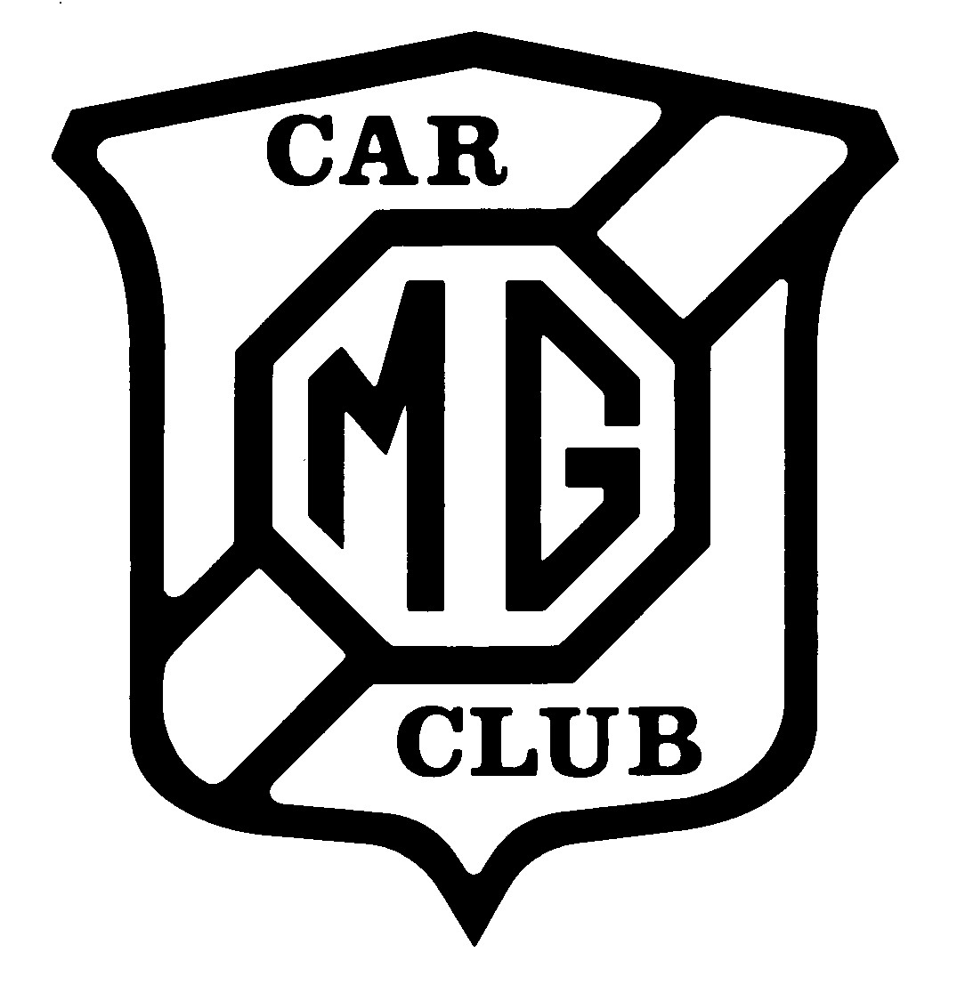

Suplementary Regulations and Entry Form

ENTRY FORM

The Scammonden Hillclimb

Sunday 26th May 2024

Organised by the MG Car Club (North Western Centre)

PLEASE USE A SEPARATE FORM FOR EACH CAR/DRIVER
IF THE ENTRANT AND THE DRIVER ARE THE SAME ONLY THE DRIVER SECTION NEED BE COMPLETED
PLEASE USE BLOCK LETTERS

ENTRANT DETAILS | DRIVER DETAILS
NAME ................................................................. | NAME .......................................................................
ADDRESS ........................................................... | ADDRESS ...............................................................
............................................................................ | .................................................................................
TELEPHONE (Home) ......................................... | TELEPHONE (Home) ..............................................
(Business) ........................................................... | (Business) ...............................................................
Entrant's Licence No. ......................................... | Comp. Lic. & No. .....................................................

Drivers e-mail address (please print)………………………………
Do you hold or have you ever held a valid Road Traffic Licence YES……..……….NO..…….…..…
Signature ............................................................ Signature .................................................................

CAR DETAILS
MAKE/MODEL ................................................... CAPACITY ..............................................................
CLASS ENTERED ............................................. SUPER/TURBO CHARGED .................... .YES/NO
CAR SHARED WITH ......................................... Petrol Yes/No Diesel Yes/No Hybrid Yes/No
COLOUR……………………………………………. CHAMPIONSHIP ....................................................
Is this vehicle self-starting? Yes/No If not, what is the method of starting?
ENTRY DETAILS
CLUB…………………… CENTRE ………………….. MEMBERSHIP NUMBER……………………

I am eligible for Beginner Award YES…………..NO……………….

I enclose entry fee of £95
Please make cheques payable to The MG Car Club (North Western Centre or by bank transfer to “For MG Car Club Ltd” sort code 53-81-36 a/c no 06004342
Closing date for entries is 18th May 2024.

Please send this form and entry fee to:
Mr P Goodman, 36, Deva Close, Poynton, Stockport, SK12 1HH Phone numbers evening 01625876300 Day 07891035923 e-mail paul.goodman7@ntlworld.com

IMPORTANT NOTE:
PLEASE ENSURE DECLARATION IS COMPLETED. ENTRIES RETURNED WITHOUT A SIGNED DECLARATION WILL BE INVALID.

GENERAL DECLARATION Entrant or Driver
I declare that I have been given the opportunity to read the General Regulations of the Motorsports UK and, if any,the Supplementary Regulations for this event and agree to be bound by them. I declare that I am physically and mentally fit and competent to take part in the event. I acknowledge that I understand the nature and type of the competition and the potential risk inherent with motor sport and agree to accept that risk. I understand that motorsport can be dangerous and accidents causing death, injury, disability and property damage can and do happen. I understand that these risks may give rise to my suffering personal injury or other loss and I acknowledge and accept these risks.
In consideration of the acceptance of this entry I agree that neither any one of or any combination of the MSA and its associated clubs, the organisers, the track owners or other occupiers, the promoters and their respective officers, servants representatives and agents (the “Parties”) shall have any liability for loss or damage which may be sustained or incurred by me as a result of participation in the event including but not limited to damage to property, economic loss or financial loss however caused. Nothing in this clause is intended to or shall be deemed to exclude or limit liability for death or personal injury. To the fullest extent permitted by law I agree to indemnify and hold harmless each of the Parties in respect of any loss or damage whatsoever and howsoever arising from my participation in the Event.
I declare that to the best of my belief the driver(s) possess(es) the standard of competence necessary for an event of the type to which this entry relates and that the vehicle entered is suitable and roadworthy for the event having regard to the course and the speeds which will be reached.

State your age if you are under 18 years .................

Parent / Guardian / Guarantor of the Driver
If I am the Parent / Guardian of the drive, I understand that I shall have the right to be present during any procedure being carried out under the Supplementary Regulations issued for this event and the General Regulations of Motorsports UK
As the Parent / Guardian / Guarantor, I confirm that I have acquainted myself and the minor with the Motorsports UK General Regulations, agree to pay any appropriate charges and fees pursuant to those Regulations (to include any appendices thereto) and hereby agree to be bound by those regulations and submit myself without reserve to the consequences resulting from those Regulations (to include any appendices thereto) and hereby agree to be bound by those Regulations and submit myself without reserve to the consequences resulting from those Regulations (and any subsequent alteration thereto). Further I agree to pay as liquidated damages any fines imposed upon me up to the maxima set out in Part 3, Appendix 1.’ Entrant
I declare that to the best of my belief the driver(s) possess(es) the standard of competence necessary for an event of the type to which this entry relates and that the vehicle entered is suitable and roadworthy for the event having regard to the course and the speeds which will be reached. I have read and fully understand the Procedure for Control of Drugs and Alcohol as contained in the Competitors’ and Officials’ Yearbook Regulations H39,d 35.1, G15.1.4, and have also fully familiarised myself with the information on the web sites referred to (www.ukad.org.uk and www.wada-ama.org) in particular the UK Anti Doping Rules which have been adopted by the Motorsport UK (as amended). Further, if I am counter-signing as the Parent or Guardian of a minor then in addition to the deemed consent to the testing of that minor (UKAD Code Art 5.6.2) I hereby confirm that I give such consent for the minor concerned to be so tested. I hereby agree to abide by the Motorsport UK Child Protection Policy and Guidelines and the National Sporting Code of Conduct.

Driver
I understand that should I at the time of this event be suffering from any disability whether permanent or temporary which is likely to affect prejudicially my normal control of my vehicle, I may not take part unless I have declared such disability to the ASN which has following such declaration, issued a licence which permits me to do so.’

ENTRANT DETAILS | DRIVER DETAILS
NAME ................................................................................. | NAME ........................................................................................
SIGNATURE ...................................................................... | SIGNATURE .............................................................................
AGE (if under 18)................................................................. | AGE (if under 18) .......................................................................
NAME OF PARENT OR GUARDIAN IF UNDER 18 | NAME OF PARENT OR GUARDIAN IF UNDER 18
............................................................................................ | ..................................................................................................
Relationship……………………………………………… Relationship…………………………………………………

SIGNATURE OF PARENT OR GUARDIAN | SIGNATURE OF PARENT OR GUARDIAN
............................................................................................ | ..................................................................................................
ADDRESS ........................................................................... | ADDRESS ................................................................................
............................................................................................ | ..................................................................................................
TELEPHONE (Home) .......................................................... | TELEPHONE (Home) ................................................................

IN CASE OF SERIOUS ACCIDENT, NAME AND ADDRESS OF FRIEND OR RELATIVE TO BE INFORMED:

.......................................................................................................................................Telephone........................

